* **INSTALING NODE JS**

Node JS is the JS RUN TIME which add some features to JS so it can run of servers, so node js is just like other programming languages which can run on Systems (while js is for the browser purpose)

Node js use V8 which is Google compiler which takes the js code and convert into machine code in browser.

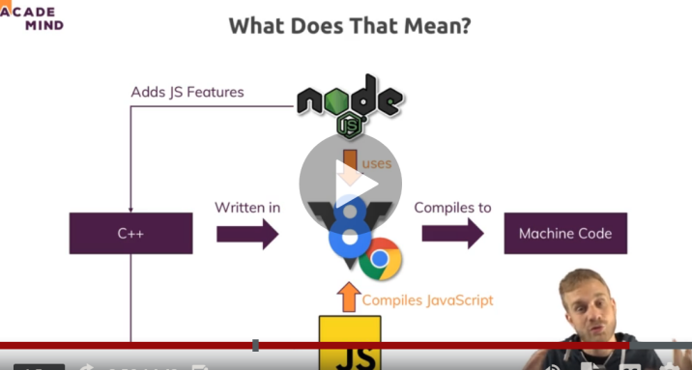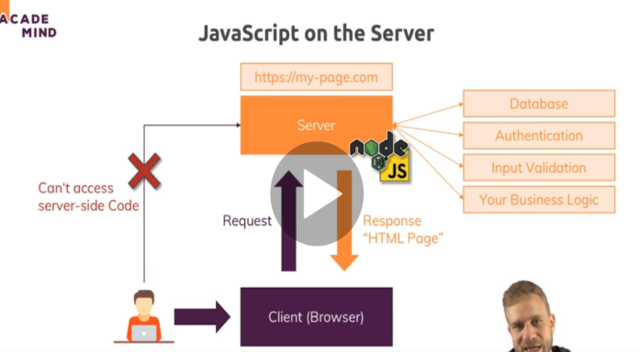

* Run node in vs code with terminal

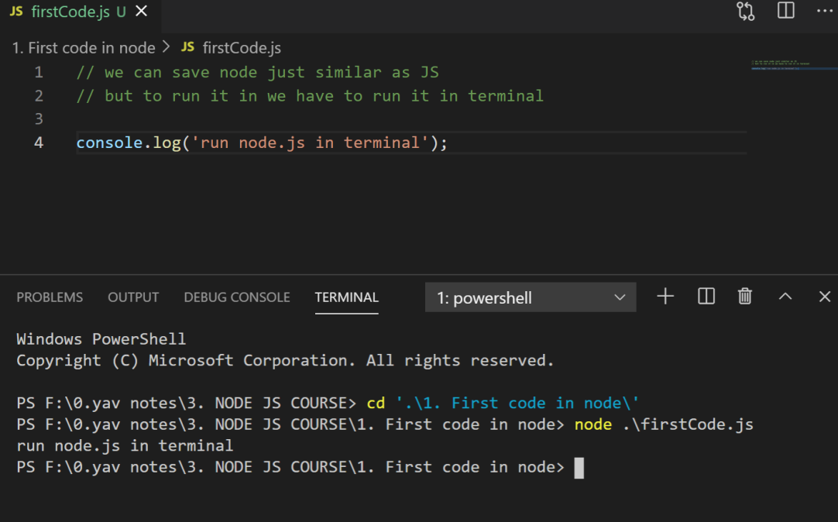

Q SO how node js is working in server side

So when user enters url this url converted by domain lookup and sends the request to the server side where node js plays a work to handles a data from data base and give response back to the client in form of html page.

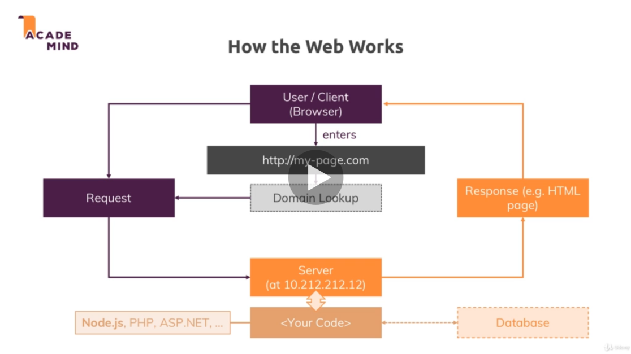

So to send from putting a request to getting it all the work done under standardized protocol which is HTTP and HTTPS but in https data is encrypted and secured.

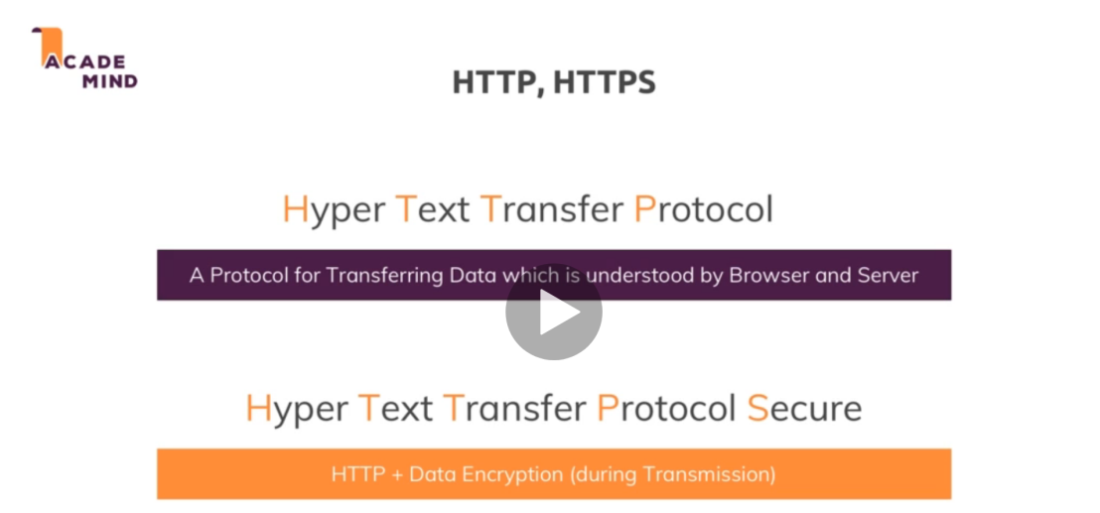

Some of the core module of node js which are most in use are

